**Chapter 10 - Biotechnology**

**All Lectures Uploaded on YouTube:**

[**https://tinyurl.com/fkm10-biology**](https://tinyurl.com/fkm10-biology)

## 

# **10.1 Introduction To Biotechnology**

* Biotechnology has existed since early human civilization through activities like planting crops, domesticating animals, producing yogurt, cheese, wine, beer, and baking bread.
* Early farmers practiced grafting to improve plant yield and quality—an early form of biotechnology.
* Increase in global population pushed humans to develop more nutritious, pest-resistant crops and improved animal breeds.
* Biotechnology is defined as **the use of living organisms or their products for human welfare**.
* Traditional biotechnology used microorganisms like yeast for fermentation and bacteria for dairy products.
* Leather tanning is also an ancient biotechnological process.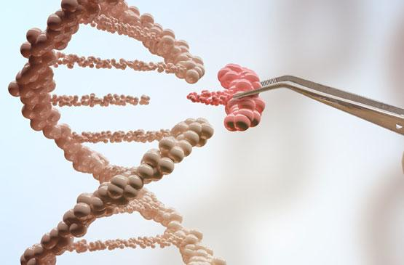
* Modern biotechnology emerged with advancements in microscopy and cellular biochemical understanding.
* Includes: **genetic engineering, cell fusion, GMOs, cell therapies, gene therapies, nanobiotechnology, single-cell proteins**.
* Modern biotechnology is a priority scientific field in Pakistan and a major part of global scientific development.

# **10.2 Food Biotechnology Related To Advanced Agriculture In Pakistan**

* Pakistan (population ~240 million) faces rising food demand, shrinking farmland, and environmental challenges.

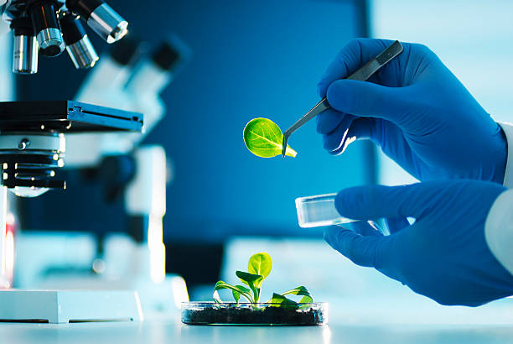

* Food biotechnology helps improve food yield, nutritional value, resistance to pests, environmental resilience, processing and preservation.
* Pakistani institutions include **NIBGE, NIAB, NCEMB, KIBGE, ASAB**—working on improving crops and livestock.

## **10.2.1 Genetically Modified (GM) Crops**

* GM crops (wheat, rice, maize, sugarcane) are engineered for pest resistance, environmental tolerance, and improved yield.

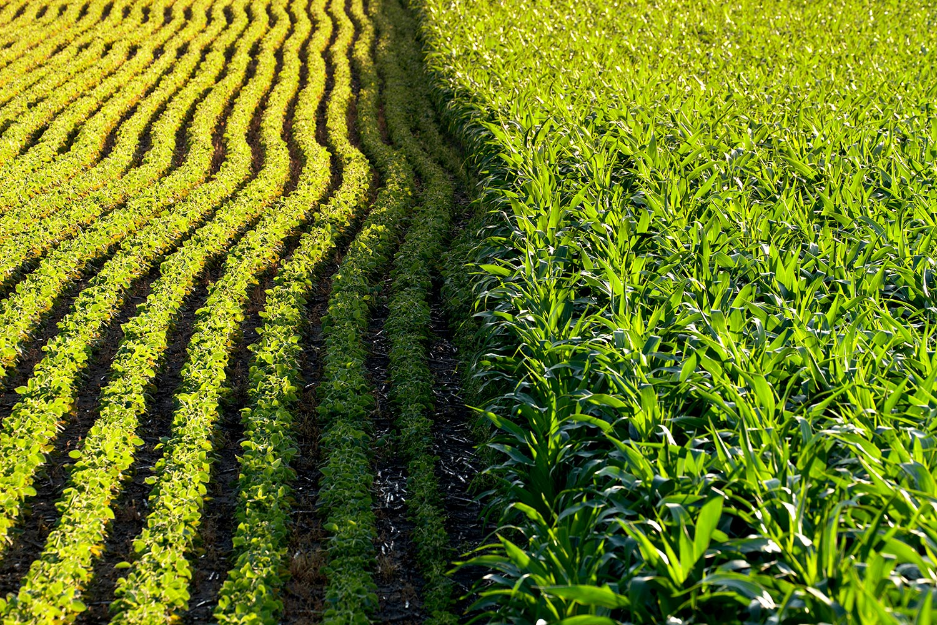

### **Key Examples in Pakistan**

* **Bt Cotton (Cry gene from *Bacillus thuringiensis*)**
  + Resistant to viruses, cotton flies, bollworms.
  + Higher productivity, reduced pesticide use, increased cotton oil and seed cake production.

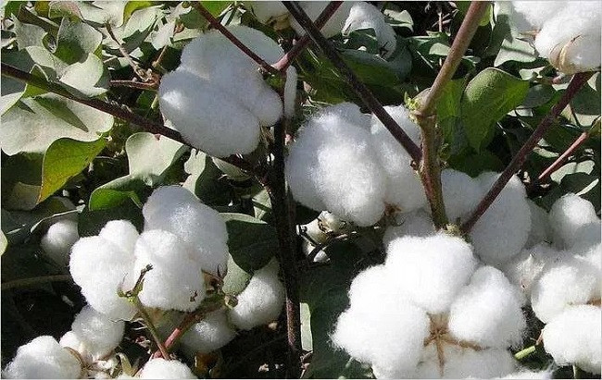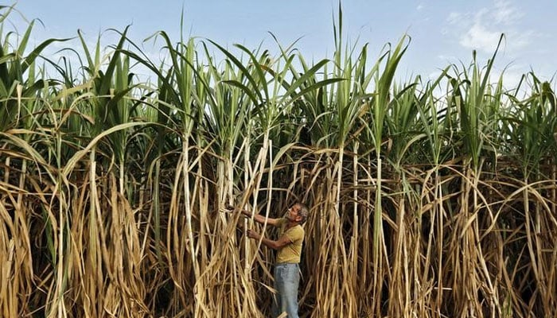

* **GM Sugarcane**
  + Cry1Ac + Cry2Ab genes → resistance to sugarcane top borer.
  + Higher sugar yield.
* **GM Wheat / Sugarcane / Potato**
  + Grow in phosphate-deficient soils (AVP1 gene).
  + Resistant to drought, heat, and frost.
* **Herbicide-resistant Wheat** (CP4-epsps gene)
* **GM Tomatoes and Chilies** are also under development and cultivation.

## **10.2.2 Improved Nutritional Content (Bio-fortification)**

* Bio-fortification enriches crops with essential nutrients (Vitamin A, iron, zinc).
* Pakistan developed 5 zinc-enriched wheat varieties:  
  1. Zincol-2016
  2. Akbar-2019
  3. Nawab-2021
  4. Tarnab Rehbar
  5. Tarnab Gandum-1
* Contain **40% more zinc**, improve public nutrition, and offer high yield + rust resistance.

## **10.2.3 Disease-Resistant Food Crops**

* Biotechnology enables crops resistant to diseases such as wheat rust.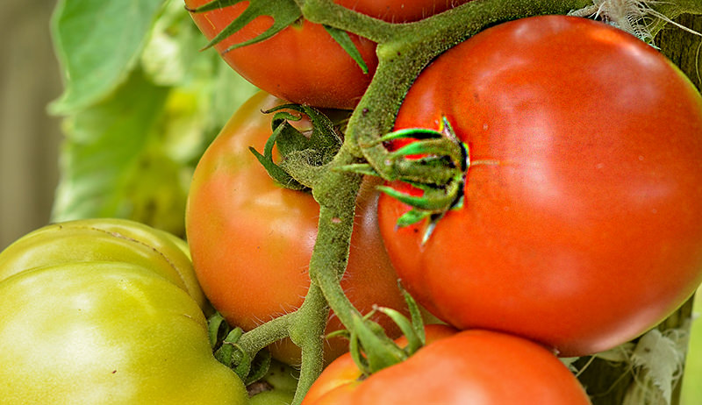
* Rust-resistant genes identified and transformed into local varieties (e.g., Seher-2006, Punjab-11).
* Expected to improve national wheat production.

## **10.2.4 Drought and Salinity Tolerance**

* Pakistan faces drought, floods, salinity, and waterlogging.
* New GM wheat and maize varieties developed to tolerate water scarcity and salinity.
* Help maintain yield despite irregular rainfall.

## **10.2.5 Improved Livestock Productivity**

* Biotechnology improves dairy and meat quality via:  
  + Embryo transfer
  + Artificial insemination
  + Hybrid cattle breeding
  + Disease-resistant poultry and dairy breeds
* Leads to increased productivity and better rural livelihoods.

## **10.2.6 Food Processing**

* Biotechnology enhances food safety, preservation, value addition, and storage.

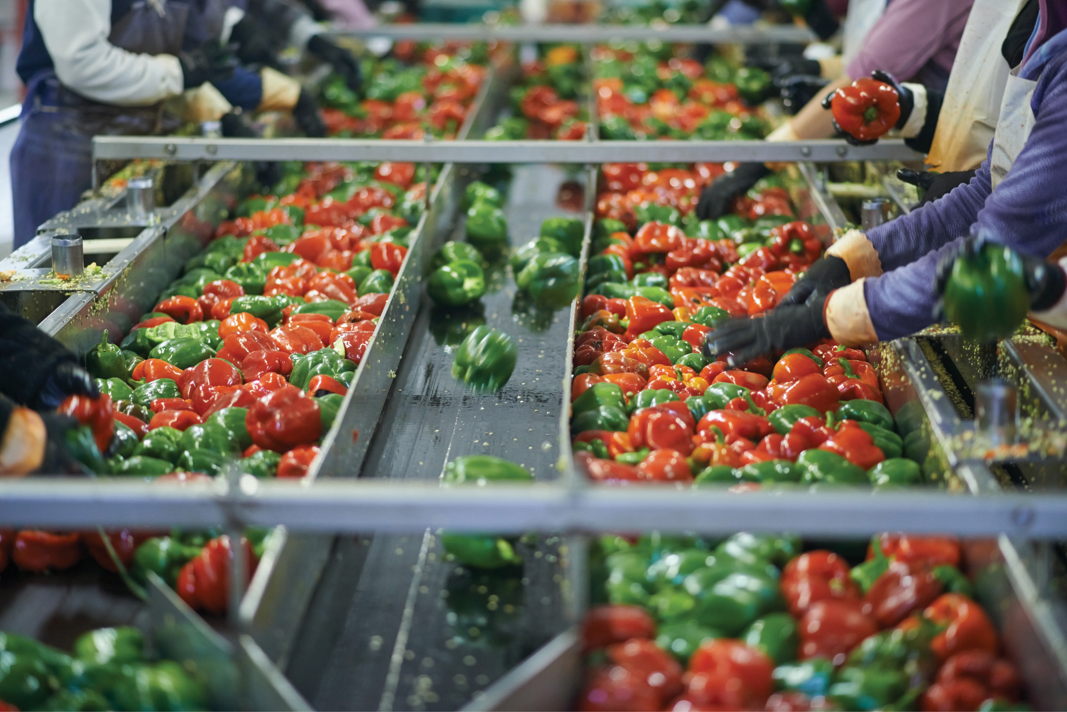

### **Applications**

* **Food preservation:** canning, refrigeration, pasteurization, drying, smoking, fermentation.
* **Food preparation:** grinding, cooking, mixing.
* **Food safety:** reducing contamination.
* **Value-added processing:** nutrient-rich foods, additives, flavors, colors.

## **10.2.7 Biological Pest Control**

* Biotechnology creates environmentally friendly pest management methods.
* Modified viruses, bacteria, and insects help protect crops.
* Bio-pesticides reduce reliance on harmful chemicals.

# **10.3 Medical Biotechnology In Advancement Of Healthcare In Diabetes And Cancer**

Uses living cells/organisms to produce pharmaceuticals and diagnostics.

## **10.3.1 Diabetes**

### **Diagnosis**

* **Biosensors (Glucose meters):** electrodes detect enzymatic reactions with glucose → electrical signal proportional to glucose level.
* **Continuous Glucose Monitoring (CGM):** real-time glucose tracking; helps adjust insulin dosage and diet.
* **HbA1c assays:** reflect average glucose levels over 3 months.
* **Biomarkers:** identified for early detection and disease monitoring.

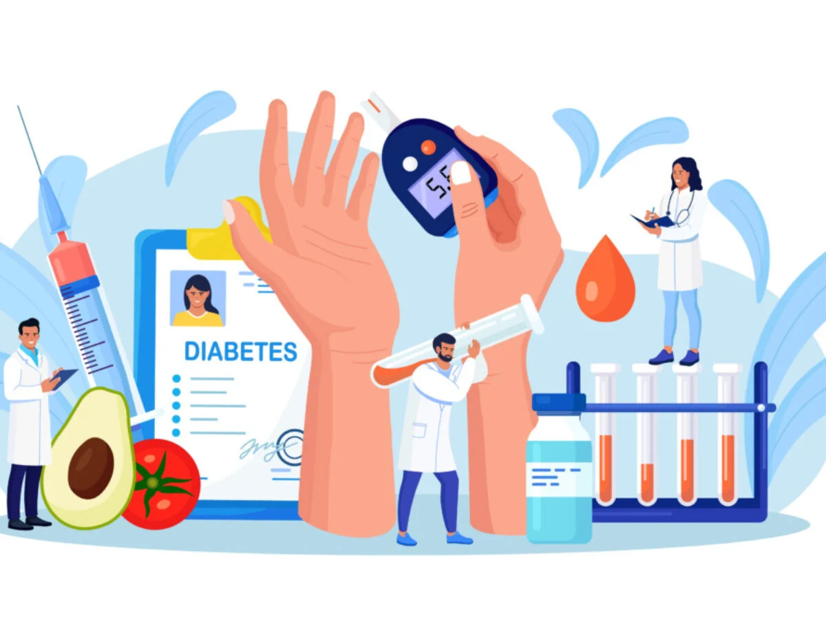

## **10.3.1.2 Insulin Production**

* Previously obtained from animals.
* Now produced using **recombinant DNA technology** in genetically modified bacteria → pure, safe, large-scale human insulin.

**10.3.4.3 Artificial Pancreas**

* Closed-loop insulin delivery system.
* Combines sensor + computer algorithm + insulin pump.
* Automatically adjusts insulin based on real-time glucose → better control and fewer complications.

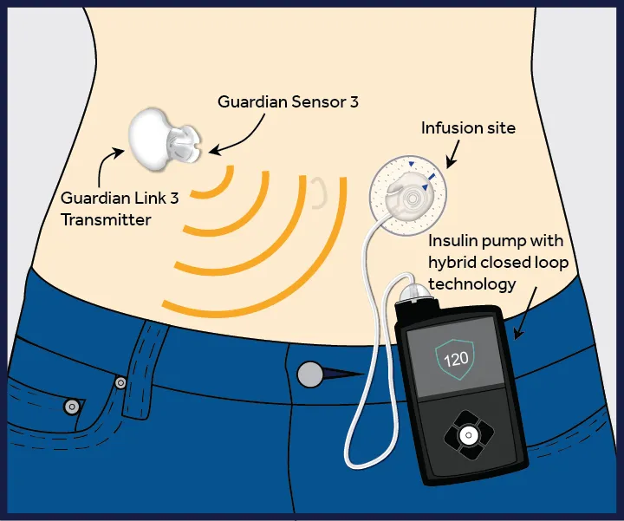

## **10.3.4 Cancer**

Cancer arises from uncontrolled cell division; may be benign or malignant (spreading = metastasis).

Common cancers: lung, breast, prostate, oral, colorectal.  
Pakistan (2022): 185,748 new cases; 118,631 deaths.

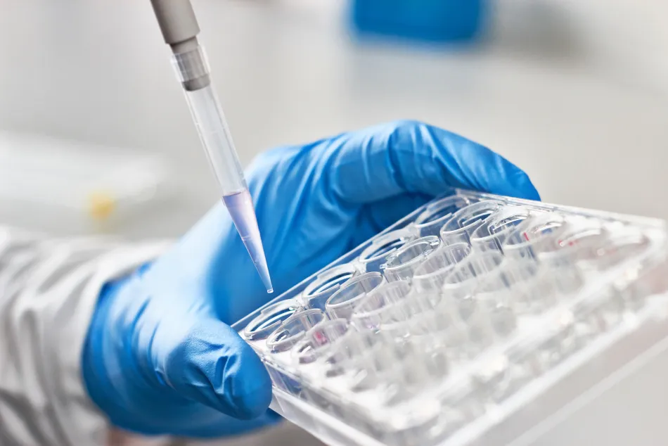

### **Biotechnological Contributions**

#### **Early and Accurate Diagnosis**

* Study of cancer cell lines → identify genes/proteins involved in cancer.
* Protein biomarkers (HER2/neu, CA125) used for early detection.
* Tumor suppressor gene mutations (BRCA1/BRCA2) linked to high cancer risk.
* Gene knockdown/knockout in cells verifies gene function.
* Animal models confirm genetic roles.
* Liquid biopsy developed for non-invasive detection (CTCs, cfDNA).

#### **Result-Oriented Targeted Therapies**

* Targeted drugs affect only cancer cells → fewer side effects.
* Monoclonal antibodies (e.g., Herceptin) block specific pathways.
* Allows higher safe dosages and improved treatment success.

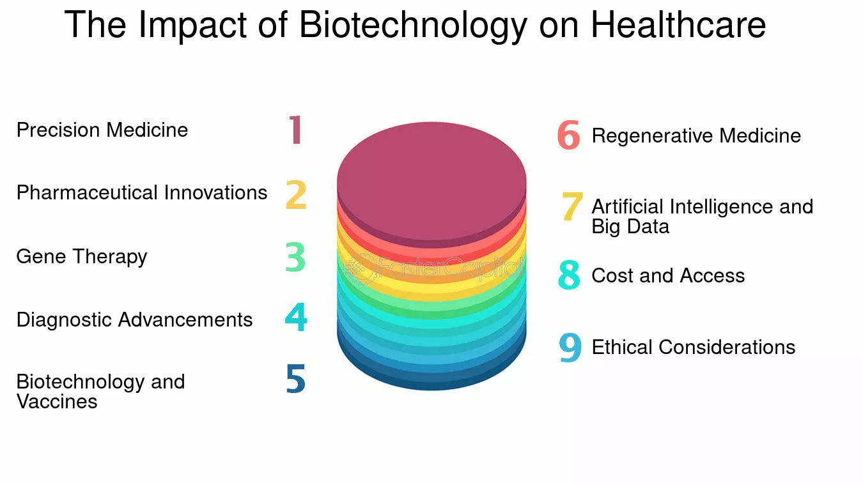

#### **Patient-Specific Medicine**

* Personalized treatments based on genetic profile, cancer stage, age, gender.
* Study of drug action using cancer cell lines and animal models.

#### **Continuous Research & Innovative Tools**

* Liquid biopsy
* Next-generation sequencing
* Monoclonal antibodies
* Immunotherapy (engineered T-cells)
* Gene knockdown/knockout
* Cancer vaccines and oncolytic viruses
* Nanoparticle-based drug delivery
* AI for analyzing cancer patterns and predicting treatments

# **10.4 Potential Advantages Of Genetic Editing With Examples In Medicine And Agriculture**

Gene editing modifies DNA by adding, removing, or altering nucleotides.

### **Two methods**

1. **Ex-vivo / In-vitro:** cells removed and edited in lab.
2. **In-vivo:** editing tools delivered directly inside the body.

## **Major Gene Editing Techniques**

### **1. CRISPR–Cas9**

* Guide RNA directs Cas9 enzyme to cut DNA at target site.
* CRISPR sequences originate from bacterial immunity against viruses.

### **2. TALENs**

* Protein recognizes specific DNA sequence + nuclease cuts DNA.

### **3. Zinc-Finger Nucleases (ZFNs)**

* DNA-binding proteins fused with nucleases to create breaks at precise sites.

### **Base Editing**

* Alters individual nucleotides without cutting DNA strands.

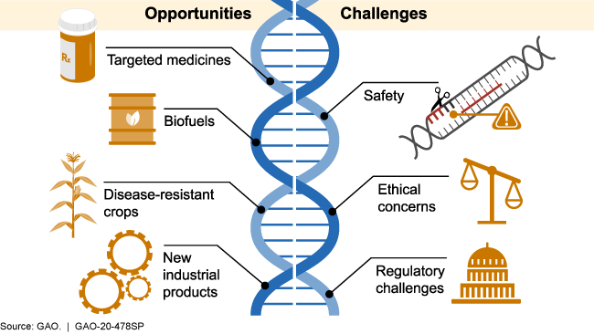

## **10.4.1 Medicine**

### **Managing Genetic Diseases**

Examples: Thalassemia, Sickle Cell Anemia, Cystic Fibrosis, Duchenne Muscular Dystrophy.

### **Drug Development & Preclinical Testing**

* Humanized mice used to test new drugs.
* Gene knockout cell lines used to test response to specific genetic defects.

### **Cancer Therapy**

* Knockout cancer-promoting genes.
* Modify genes responsible for chemotherapy resistance.
* Create targeted cancer treatments.

### **Viral Resistance**

* Editing genes like CCR5 for resistance to HIV and hepatitis.

## **10.4.2 Agriculture**

### **Improvement in Food Crops**

* CRISPR used to make disease-resistant, pest-resistant, drought-tolerant crops.
* Improves yield, taste, nutrition (e.g., rice, maize, wheat).

### **Improvement in Dairy Livestock**

* Gene modification improves milk/meat production.
* Enhances disease resistance.
* Example: myostatin gene modification increases muscle mass.

### **Environment-Friendly Farming**

* Gene editing reduces pesticide need by creating pest-resistant varieties.

### **Bioethical Limitations**

* Safety concerns
* Unequal access
* Unpredictable long-term effects
* Need for strict regulation

# **10.5 Benefits Of Marine Biotechnology**

Marine biotechnology ("blue biotech") uses marine organisms for medicine, cosmetics, food, fuel, and environmental protection.

### **Discovery of New Pharmaceutical Drugs**

* Marine organisms (sponges, algae, bacteria) produce unique chemical compounds.
* Drug examples:  
  + **Ziconotide** – pain treatment (from cone snail).
  + **Trabectedin** – cancer treatment (from marine tunicate).

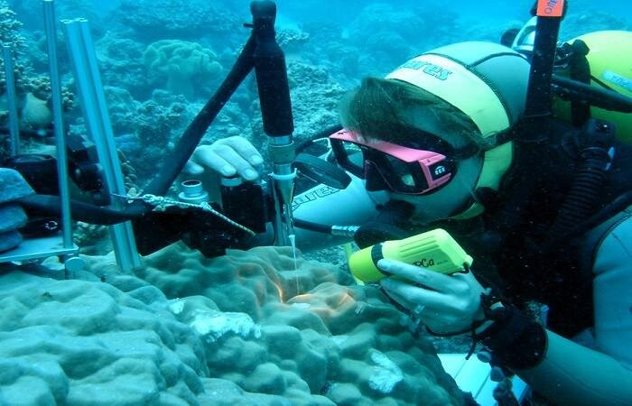

### **Medicinal & Cosmetic Products**

* Marine fish/algae → omega-3 supplements for heart & brain health.
* Algae/seaweed used in moisturizers, anti-aging creams, antioxidants.
* Astaxanthin (from microalgae/shrimps) used in skin allergy medicines.

### **Improved Aqua-Feed Formulation**

* Algae and seaweed used to produce high-quality feed for fish/shrimp farming.
* Improves growth and reduces disease.

### **Marine Enzymes with Unique Properties**

* Work in extreme temperature, pressure, pH.
* Used in:  
  + Food processing
  + Cosmetic industry
  + Detergents
  + Textile industry

Examples:

* α-amylase
* β-agarase
* Xylanase

### **Genetically Modified Aquaculture**

* Produces disease-resistant and nutritious fish species.
* Genetic study of marine organisms helps improve stability and resilience.

### **Biofuels from Marine Algae**

* Marine microalgae produce lipids → biodiesel.
* Grow in saline water, reducing freshwater usage.
* Renewable energy source.

### **Bioremediation**

* Marine bacteria/fungi naturally degrade oil, plastics, heavy metals.
* Example: *Alcanivorax borkumensis* breaks down crude oil.

# **10.6 Bioremediation: Taking Better Care Of Our Environment**

Bioremediation uses microorganisms and plants to detoxify polluted soil, water, and air.

## **Types**

1. **In-situ:** treatment at contamination site.
2. **Ex-situ:** removal and treatment at another location.

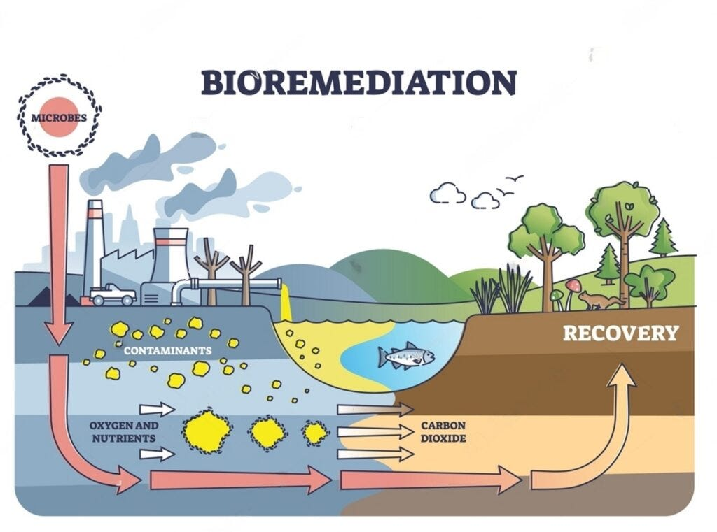

## **Advantages**

* Natural and sustainable
* Cost-effective
* Requires minimal machinery
* Environmentally friendly (less chemical use)
* Supports long-term ecosystem health
* Microbes can be genetically engineered
* Applicable for:  
  + Oil spills
  + Heavy metal contamination
  + Pesticide degradation

## **Mechanism**

1. Microorganisms are stimulated to grow in polluted environments.
2. They use pollutants as energy/food.
3. Convert them into harmless substances (CO₂, water).
4. The process requires proper temperature, oxygen, moisture, and nutrients.
5. Bioremediation can be accelerated by adding nutrients or air.

## **Examples in Pakistan**

### **1. Tasman Spirit Oil Spill (Karachi)**

* NIBGE introduced oil-degrading bacteria.
* The 75-day treatment cleaned the sandy shore.

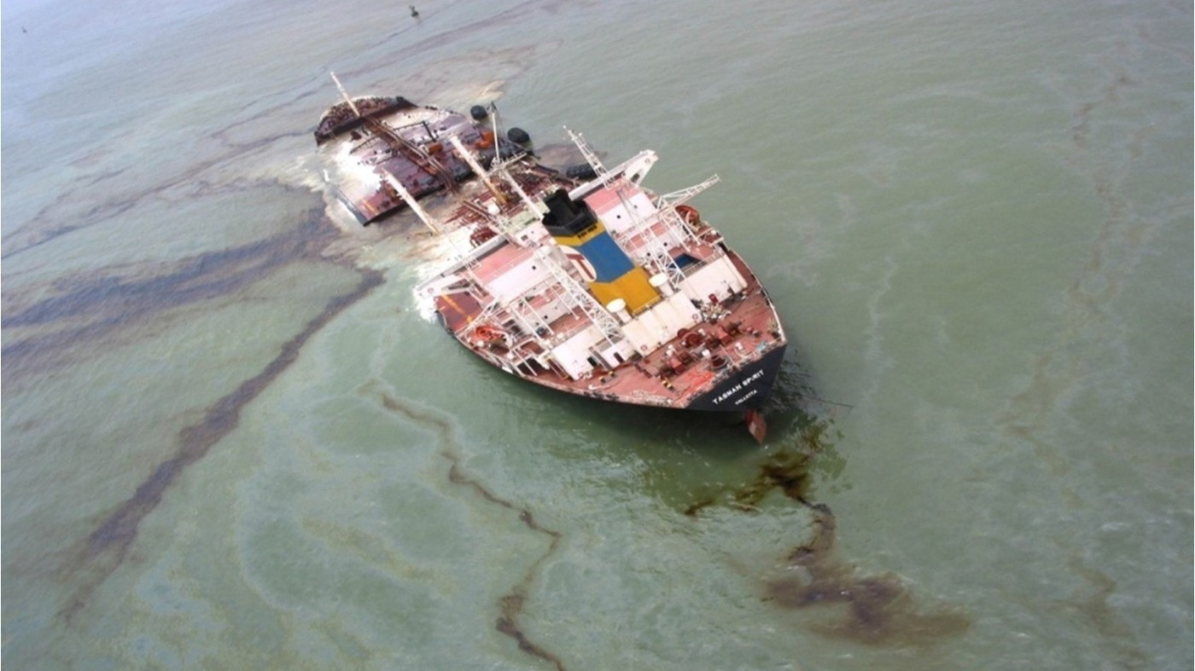

### **2. Lahore Industrial Waste**

* Heavy metals and toxins from tanneries, paints, textile industries.
* Wetland-based bioremediation using plants + microbes to clean water.

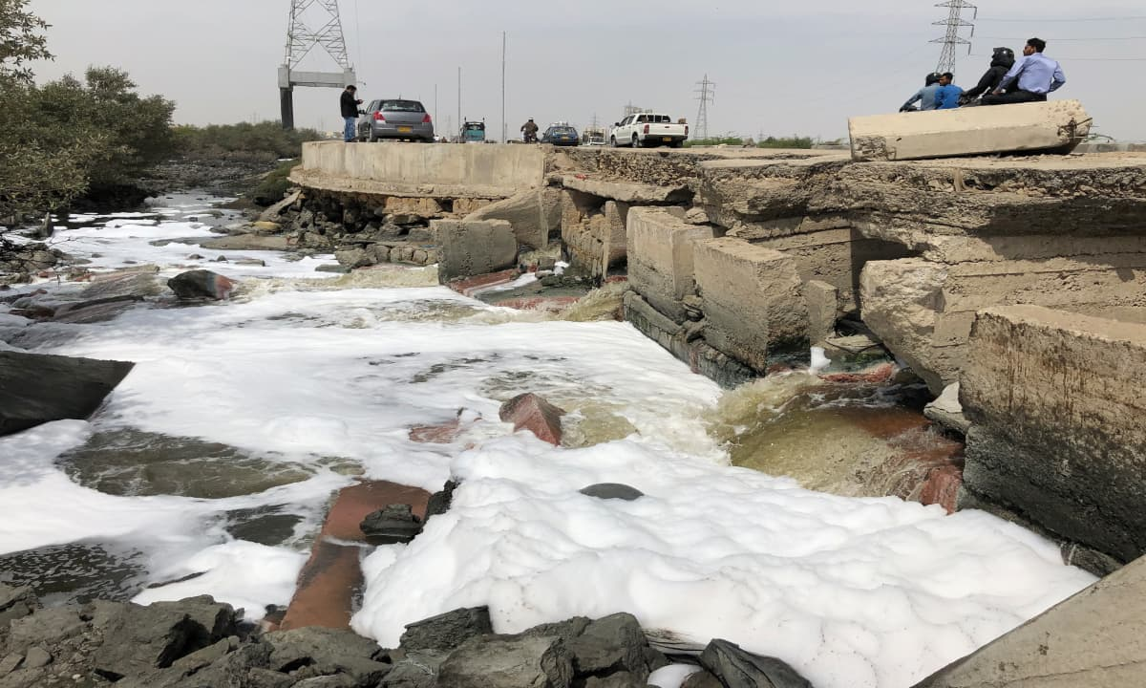

## **Concept and Applications of Industrial Biotechnology (White Biotechnology)**

Uses microorganisms, enzymes, and plants to produce industrial products sustainably.

### **Components**

* Microorganisms
* Enzymes
* Biological system manipulation
* Genetic engineering

## **Applications**

### **1. Food & Beverage**

* Fermentation (baking, brewing)
* Rennet enzyme for cheese production
* Amylase for starch breakdown

### **2. Biopharmaceuticals**

* Large-scale production of insulin, vaccines, vitamins, antibodies.

### **3. Agriculture**

* Bio-fertilizers, bio-pesticides.
* Genetic engineering for crop improvement.

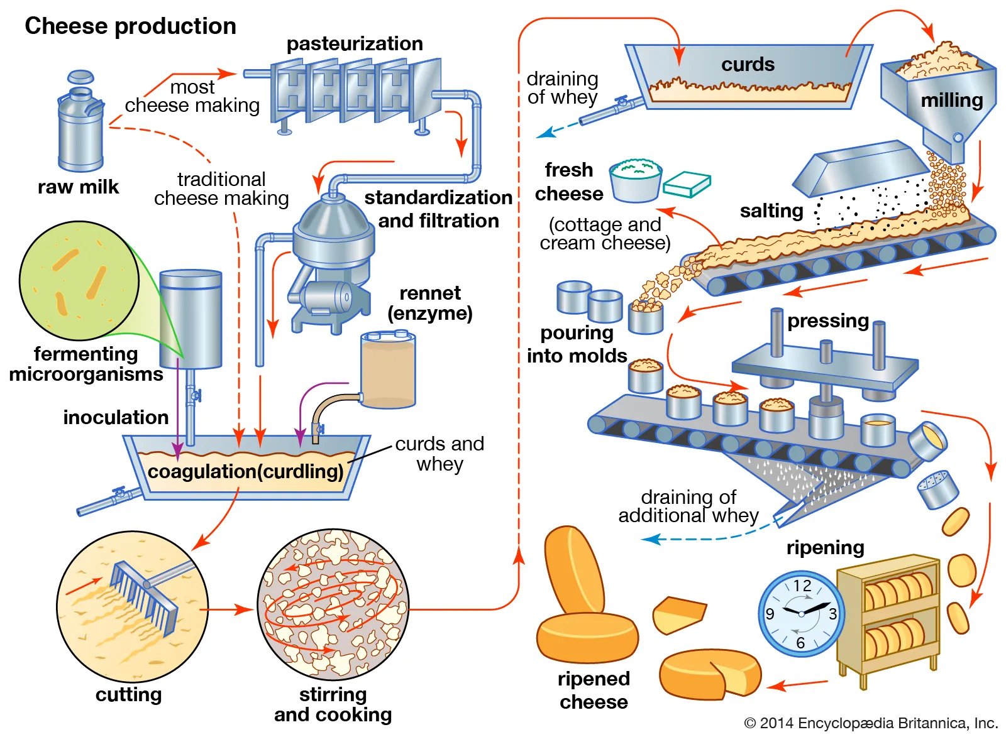

### **4. Useful Chemicals**

* Citric acid, acetic acid, acetone
* Alcohols, amino acids from fermentation

### **5. Biofuels**

* Bioethanol and biodiesel from sugarcane, corn, algae.

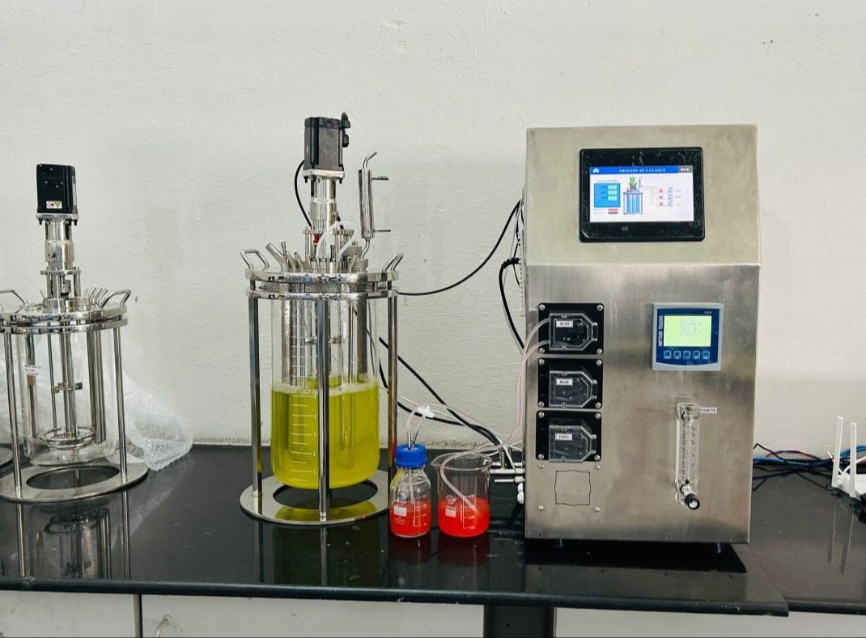

### **6. Bioremediation & Environmental Protection**

* Use of microorganisms for waste cleanup.
* Reduces pollution, supports sustainability.



